Active and passive safety of motorcycles with reference to sitting geometry
Martin Šotola^{A}, Martin Hönig^{B}, Jiří First^{C}

Abstract — Vehicle sitting geometry is very important parameter for motorcycle active and passive safety. It influences riding, operating and condition safety. In term of the passive safety testing sitting geometry parameters give a sup-position to rider’s trajectory and contact zones on his body. Our institute performed several tests with frontal crash to a car and analyses the influence of different seat shapes and positions on the results of the crash tests.

Key Words — motorcycle, sitting geometry, active safety, maneuvering, ergonomics, monotonicity, seat, steering handlebars, footrests, condition safety, operation safety, riding safety, motorcycle passive safety, crash test, Madymo software, simulation

Introduction Variables
One of the most important safety elements is vehicle maneuvering. The vehicle maneuvering is characterized by several values. One of the most important parts is driver's sitting position.
The ergonomics discipline is concerning with relationship between human and machine, so called Human Machine Interaction (HMI). This discipline also studies optimal sitting geometry in vehicles. The sitting geometry is detailed sophisticated at space exploration, aero-space field and in the cars mostly. The high level of the ergonomics in these transportation systems is influenced by their use such vocational transportation systems.
Car design engineers are limited by many technical directives [11] during design of the sitting geometry, seats etc.
In the contrast to cars, for motorcycle driver’s sitting there is no particular direction in frame of European legislation. According to our information obtained from members of The Ergonomics Society there exists neither direct legislation out of Europe nor exact method for sitting geometry determination [7]. Sitting geometry is influenced indirectly for example by directives for frontal and rear driver's view, operating element placing etc.
A - Ing. Martin Šotola, e-mail: xsotola@fd.cvut.cz
B - Ing. Martin Hönig
C - Ing. Jiří First, e-mail: first@fd.cvut.cz
The authors are with Department of Transporting Technology, Faculty of Transportation Sciences, CTU in Prague, Horská 3, 128 03 Praha 2, Czech Republic
The question is – is it correct or not? The answer is currently searched at the Department of Transporting Technology of Faculty of Transportation Sciences at CTU in Prague.

Motorcycle sitting geometry definition
The sitting geometry can be defined by contact points between motorcycle and driver.
The places of contact are seat, steering handlebars and footrests. Contact isn’t a point but the area which is more difficult for the definition. So, a real contact is simplified to points with tolerance. We can simply define sitting geometry by two triangles fig. 1.
The points on the steering handlebar are in the center of gripes and the points on the foot-rests are in the center of footrest.
The contact point on the seat is necessary to define in detail, because it is soft structure with measuring tolerance problems. It is used anatomical shell from the normalized dummy ISO 6549 [12] - sitting part. The shell is loaded with 43kg during measuring. The side point on the shell is used for triangle of sitting between seat - steering handlebar (grip) - footrest. This point corresponds with reference point H (H-joint) of the standardized 50% dummy.
The summary of the sitting geometry:
- Triangle: shell side point - steering handle bar (grip) – footrest fig. 1.a)
- Triangle: left grip - right grip - center point in the shell fig. 1.b)
- Vertical distance between: seat, steering handle bars (grip) and footrest with base (roadway)

Note: Proposal methodology includes powered two wheelers (PTW) with elaborately defined footrests (e.g. scooters, cruisers) too. For brief demonstration this definition is enough, but for precision description is necessary to take into account footrest width and length and handle bars turning in two axes.

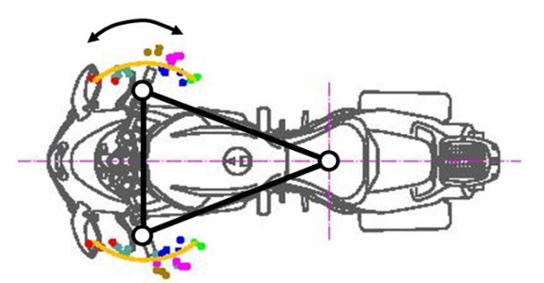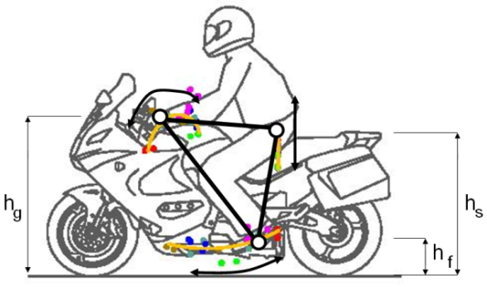
Fig. 1: Sitting triangle [8]

Sitting geometry influence on motorcycle characteristics
We can investigate every vehicle from static and dynamic point of view. We have to study complete system, it means, vehicle with driver (except automatic vehicles without human operator) during dynamic behavior. This requirement is necessary in vehicles where the mass quotient (vehicle/driver) is small - motorcycles.
For instance aerodynamic resistance is in motorcycles influenced by sitting geometry.
The frontal area (A) and coefficient of the aerodynamic resistance (cx) are influenced by sit-ting geometry too. There’s difference in comparison with cars.
Let’s go to safety questions of the drivers sitting position on the motorcycle. We can evaluate active safety from the many points of view. We can distinguish three types of safety: riding, operating and condition.

3.1Riding safety
Some elements and systems reduce accidental risk in vehicles. For example brakes and other stability influence parts eliminate drivers’ errors in the non-standard conditions. Whilst brakes and braking are exactly defined such as decelerating motion or controlled stop, stability contains large set of attributes. These attributes are influenced by drivers’ position.
Vehicle is unbalanced by inertial force
(1)

Where m is vehicle weight and is deceleration.
This force takes effect in the center of gravity and changes contact forces (ZF, ZR) between wheels (front and rear) and base. The frontal wheel is more pressed and rear less pressed. This influence grows up with the gravity center height (h).
Simplified reaction enumeration [10]:
(2)

(3)

Where Z_{F(R)stat} are static forces and h is gravity center height.

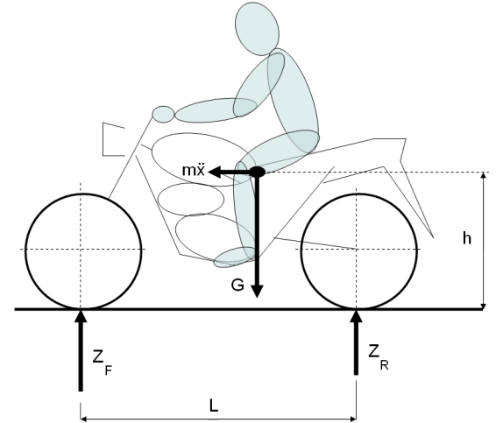
Fig. 2: The contact forces effect in the center of gravity

We are usually speaking about stability during cornering fig. 3 and fig. 4. System is destabilized by centrifugal force F.

(4)

F depends on weight (m), square of speed (v) and radius of curve (r). Force takes effect in center of gravity (T). Center of gravity location depends on driver’s position of sitting. We determine gravity center position by the three axis coordinate system: x, y, z.

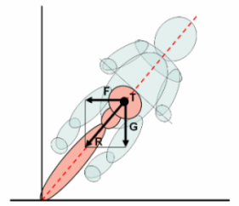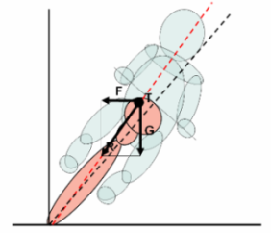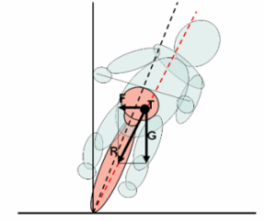
Fig. 3: Transverse force F during different sitting position (φ – roll angle, N – normal force, F - centrifugal force, Fs – lateral force)

The less mass influences acceleration and responsive handling performance positively. The distribution and location of center of mass is very often more important as the amount of mass [1].

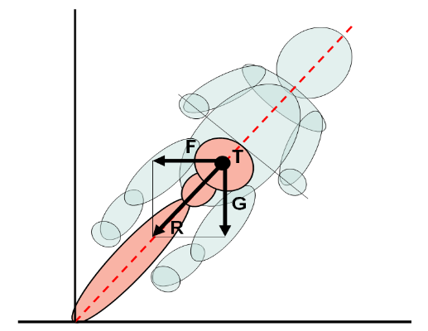
T’
y
y’
N = m.g
φ
F_{S} = N.tgφ
Fig. 4: Balance of the motorcycle on a curve

The balance is influenced by center of gravity (T, T’). The unbalancing effect equals to G multiplied by y, y’ (lever arm). Higher center of gravity (T’) brings into greater unbalancing effect. We achieve equilibrium in steady cornering when the resultant (R) of the centrifugal force (F) and gravitational force (G) passes through the vertical center line (z) of the motorcycle. It stands for simplified point of view only. For reason the different nonzero width of front and rear motorcycle wheel has the resultant force to pass through the line joining the contact areas of the tires [4].
Motorcycle dynamic is complicated and more detailed analysis isn’t subject of this text. Next motorcycles dimensions (trail, caster angle, tire size), gyroscopic effect, suspension characteristics, engine characteristics etc. influences on motorcycle handling are introduced for example in the “References” [1].

3.2 Operating safety
Easy maneuverability concerning elements on vehicle and driver: a driver sitting is influenced by operation reaches - manual and optical. Manual reaches represent characteristics of the controls (arms and pedals). Optical reach is given by drivers view forward, rearward and on dashboard instruments. It is very dependable on driver’s position. The view from motorcycle is set by legislation for homologation ECE 81[11]. Because sitting geometry is free value homologation can be granted at the cost of abnormal driver’s position. Example: differences in sitting geometry for super bike and chopper. “Lying” driver on super bike has to lean his head backwards unnaturally which causes tiredness. Chopper driver has more comfortable backward bend with better view [9].
3.3 Condition safety
Condition safety includes elements for drivers’ tiredness elimination. They are designed in the vehicle, but affected the driver entirely. Discomfort causes the drivers tiredness. Sitting geometry influences discomfort level, so that we can see the muscular and skeletal loading and monotonicity.

3.2.1. Sitting (static load)
Sitting (static load) influences carriage of body. At upright sitting on the motorcycle without back rest pelvic is tilted to the back. It causes platyspondylisis of lumbar lordosis, increase kyphosis in chest and transposition of neck vertebral column and shoulders ahead. During this way of sitting, increase pressure on the concave part of spinal lamellas and the tension on the convex side of spine. This load causes tiredness. During sitting with forward bend are conditions more favorable but increases loud by vertical forces on the spine axis. These dynamic forces are caused by asperity of the road.

% Set maximum time allowed for establishing a connection.
timeoutA=logintimeout(5)
% Connect to a database.
connA=database('SampleDB','','')
% Check the database status.
ping(connA)
% Open cursor and execute SQL statement.
cursorA=exec(connA,'select country from customers');
% Fetch the first 10 rows of data.
cursorA=fetch(cursorA,10)
% Display the data
AA=cursorA.Data
Fig. 5: Code Listing

During the monotonicity of sitting static muscular activity evokes insufficient muscular vascular and earlier tiredness. This problem is very well known at drivers’ community. Mainly during long trips any sitting isn’t optimal in the long term and it is necessary to modify it. The most of motorcycles don’t allow changing the sitting position [9].

Motorcycle sitting statistics

CTU in Prague has conducted experiments of the sitting geometry measurements on many types of motorcycles offered on the Czech market. The results of the experiment demonstrated that in fact there are significant differences between different types of motorcycles which in turn confirm the freedom of designers where the sitting geometry is concerned. Fig. 1 shows the parameters of the motorcycle sitting geometry.

5. Dynamic tests of passive safety
During the course of the past few years our department realized several types of dynamic passive safety exams also known as crash tests. Out of all the crash tests, the one point of interest is the simulation of the collision between motorcycle and passenger car. Furthermore we have used the configuration 413 according to ISO 13232 accident only where the main variable was the sitting triangle. For sitting geometry influence investigation as a consequence of traffic accident we performed three different crash tests with following 3 different sitting positioned vehicles:
- Test A. Jawa 650 (59 km/h) – Škoda Octavia (0 km/h) Side Crash test (super sport)
- Test B. Suzuki DR 600 (60 km/h) – Škoda Fabia (0 km/h) Side Crash test (traveling enduro)
- Test C. Jawa 650 Classic (50 km/h) – Škoda Felicia (0 km/h) Side Crash test (classic motorcycle)

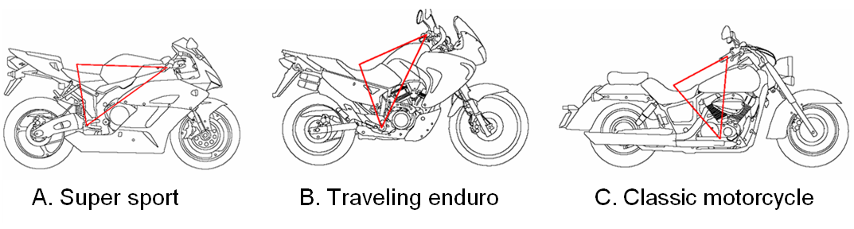
For comparative purposes, the first two crash tests are the most convenient. The reason for this is that they correspond with the same collision speed and weight of the collision partner. The fundamental difference is the sitting triangle in the case of Jawa, the driver was positioned leaning forward and adjusted according to the Super sport motorcycle. In case of Suzuki, the driver is positioned in an erect sitting position (enduro sitting position).
Together with knowledge of measured acceleration from accelerometers on the dummy’s head, chest and pelvis, we can calculate injury criteria and discover after-effects of accident.
On the fig. 8 you can see different places of collision between motorbike driver and vehicle and different trajectory because of sitting position. It is possible to see different time intervals (Jawa 650: 82 ms, Jawa 650 Classic: 99 ms and Suzuki: 100 ms). This interval determines time between the first contact of motorbike with passenger car and primary impact of dummy on hard-set structure of body. Trajectory of the driver within above-mentioned time interval has to be taken into account for the draft of safety restrain system like airbag in Madymo software. Tab.1. includes values of the head injury criterion measured and calculated for the head of dummy during crash tests.

Tab. 1: HIC – Head Injury Criterion
Test | HIC
 | primary impact
A | 2296
B | 1892
C | 63

Madymo simulation
The Main goal of MADYMO model creation was real experiment simulation performance CTU in Prague and compare results of computer simulation with reality [5]. Like inertial system was chosen the land (PLANES), to whose every motion was outspread. To this inertial system were outspread four models. First model is the model of motorbike JAWA 650 Classic, which geometry was generated on the base of construction drawing of producer. Second model is model of car, which picked some important geometry properties from ŠKODA Felicia. Base of model become videlicet model of vehicle included in database MADYMO with already predefined material properties. The third model is the dummy model HYBRID III 50th represents 50% human, which is also included in database MADYMO. Forth and last model is model of helmet with material properties contained in directive ECE-R22.
Fig. 6: Sitting geometry positions on the motorcycles A, B and C [3]

Conclusion
Increasing safety is one of the most important tasks in traffic. We will continue in these procedures for example by experiments with following targets:
- To develop an integrated methodology for motorcycle sitting geometry and to offer it to the legislation approval process.
- To propose sitting evaluative criteria in term of safety.
- To confirm or controvert hypotheses about sitting position influence on motorcycle characteristics.
- Continue with multi-body and FE models

Actual research results led to proposals improving sitting conditions and a patent (PV 2007-405) was registered. Content of the patent is continuous modification of the sitting geometry during motorcycle moving like a functionality on speed, aerodynamic resistance, requirements of the driver or different parameters. Also mathematical simulations show that for motorcycle passive safety research and development will be necessary tools.

Acknowledgment
The research was supported by the project of Ministry of Industry and Trade FT-TA/024. The presentation of this work was supported by IG CTU0815316.

References
- Bouchner P., Novotný S., System with driving simulation device for HMI measurements, 8th WSEAS International Conference on SYSTEMS (part of the 8th CSCC Multiconference), Athens,2005
- Bouchner P., Novotný S., Piekník R., Measurements and analysis of data measured from real car driving used for development of research driving simulators, CTU Workshop, Prague, 2007
- Bouchner, P., Driver’s Micro-sleeps Detection Using Virtual Simulation, In: SSGRR - 2004, NNW 14. Piacenta: ICS UNIDO, 2004, vol. 1, pg. 3-15.
- Bouchner, P., VR Simulation Device as a Support for Research in Driver's Micro-sleeps and Attention Decrease Detection , TRANSTEC 2004, Athens, Greece, 2004, vol. 1, pg. 65-72.
- Edwards M., Improving safety with on-board monitoring and control systems using CAN technology, CIA, iCC 10th international CAN Conference 2005
- Nordmark S., Palmkvist G., Sehammar H., Recent and future improvements the VTI DRIVING SIMULATOR with special emphasis on the steering system and moving base, Driving Simulation Conference, Sophia Antipolis, 2001

